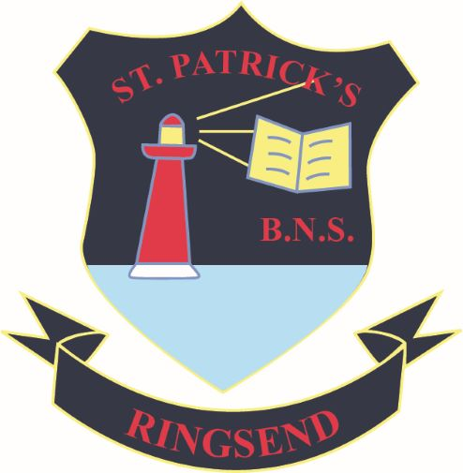
ADMISSIONS NOTICE 2026-2027
St Patrick’s BNS Ringsend will accept applications for admission to the school for the academic year 2025-2026 from October 1st 2025 until November 21st, 2025. Late applications will be accepted after this date. We will have up to 48 places in our two Junior Infants classes.
Our Junior Infants class will be our first to be mixed as we will be amalgamating with St Patrick’s GNS for the 2026-2027 school year.
Our admissions policy, enrolment forms and admissions notice are available on our website www.stpatricksbnsringsend.ie or by emailing ringsendbns@gmail.com

