
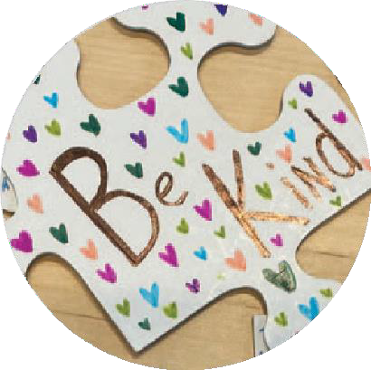








Bí Cineálta Policy 

Bí Cineálta!
We want everyone at our school to feel safe and happy.
If you think that you are being bullied or someone else is being bullied, you need to tell a teacher or another adult that you trust. They will know what to do to help.

Get help! Tell someone!

If a student tells a staﬀ member that they think they are being bullied, we will:
- talk with the student
- ask the student what they want to happen
- work out a plan together
- talk to their parents
- talk to the other student(s) involved
- talk with the other student’s parents

Bullying behaviour is when someone keeps being mean or hurtful to others on purpose over and over again.

Please
tell someone if you think that you are being bullied or someone else is being bullied.

Our school
has a Bí Cineálta policy to try to stop
bullying behaviour.

We look at this policy every year to see what is working well or what could
work better.
We will ask you what you think.

When it happens a lot. Not just once.




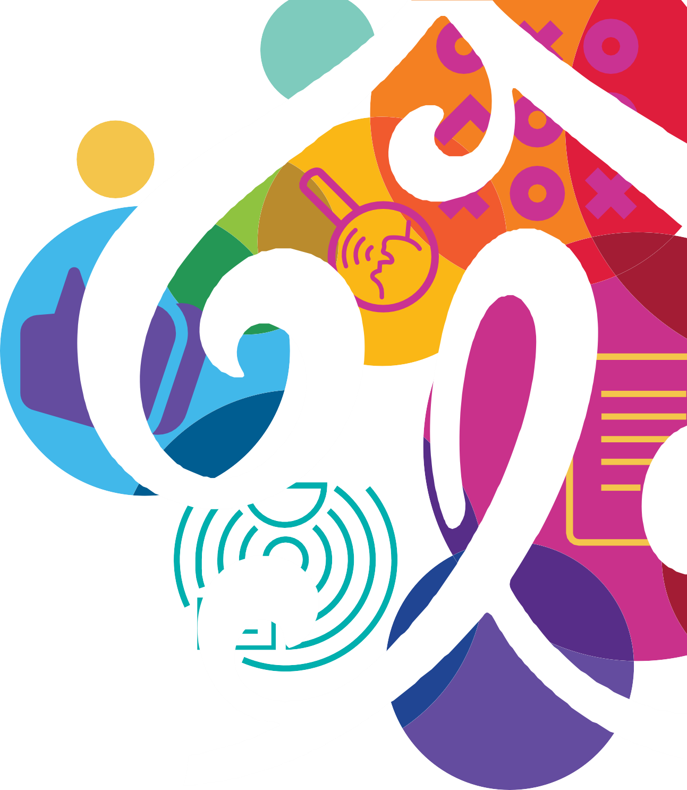
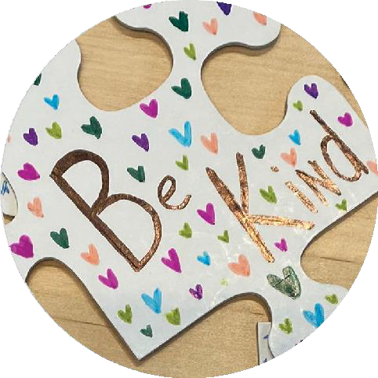

Main Heading

To get started, just tap or click this placeholder text and begin typing.
Use paragraph styles to give your document a consistent look. For example, this paragraph uses Body style. You can change it in the Text tab of the Format controls.

